Automated Night Lighting System

Here we put forth a fully automated night lighting system that detects light condition and switches on or off a load/bulb based on the light intensity. The system uses a LDR along with 555 timer and relay based circuitry with AC load connection in order to achieve this result. As soon as the light intensity falling on the LDR drops below a certain level, the circuitry uses a 555 timer based circuit to drive a relay for specific time duration. This process keep happening over time and the load is switched on through a relay as long as there are night/low light conditions. As soon as lighting increases the system switched off the load to turn of the lighting. Thus we have a fully automated night lighting system.
Block Diagram:
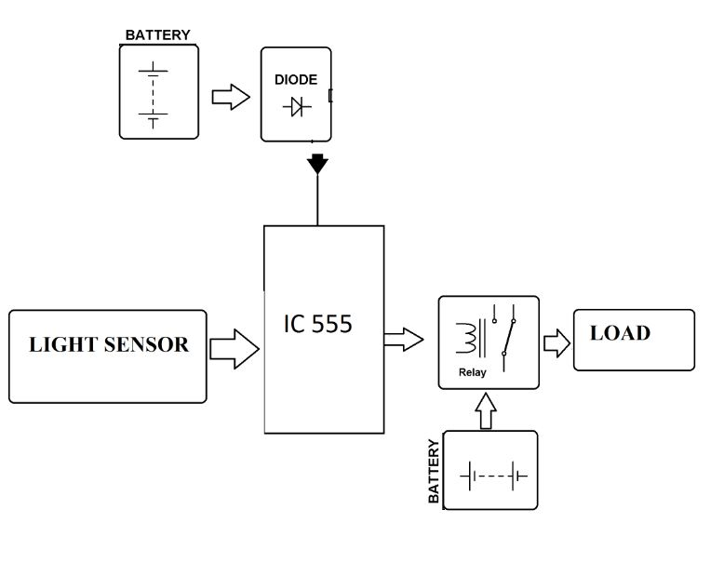

Hardware Specifications:
- Relay
- LDR
- 555 Timer IC
- Connectors
- Resistors
- Capacitors
- Diodes
- Cables & Wires

